**SET PASSWORD TO REDIS SERVER (SESSION CACHE CONTROL)**

**REF:**

<https://stackoverflow.com/questions/7537905/redis-set-a-password-for-redis>

<https://github.com/NodeRedis/node_redis>

ONCE LOGGED TO OUR UBUTU SERVER, NEXT WE DO IS MODIFY ***/etc/redis/redis.conf*** FILE TO SET PASSWORD TO REDIS SERVER:

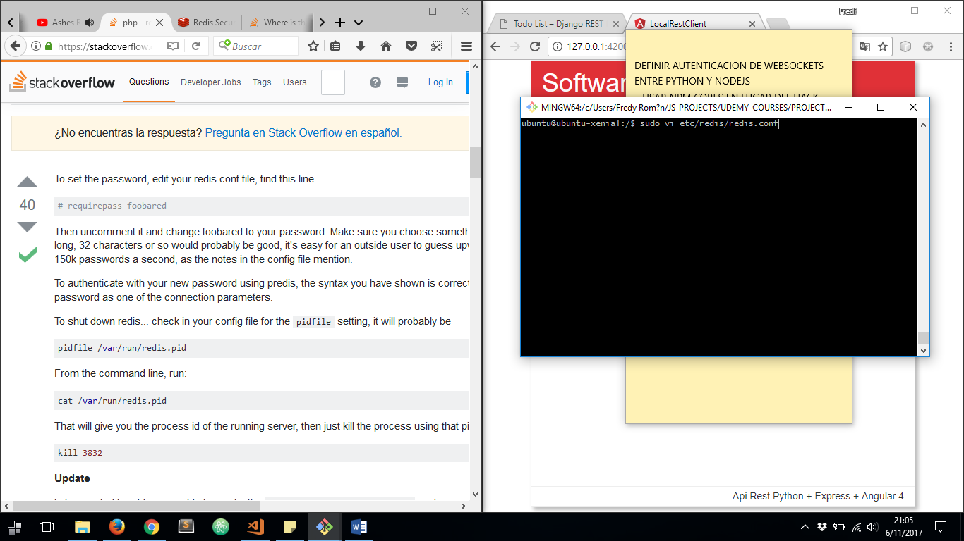

THERE WE HAVE TO LOCALE SECURITY SECTION AND UNCOMMENT ***requirepass*** PROPERTY AND SET OUR PASSWORD:

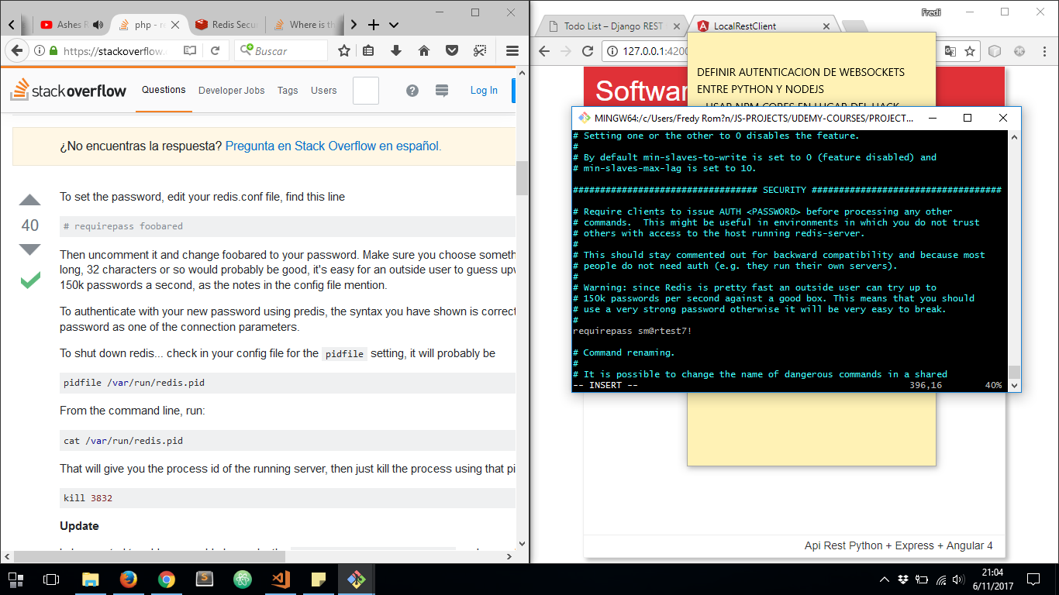

THEN WE HAVE TO CREATE A CONFIGURATION FILE TO SPECIFY SERVER CONNECTION CREDENTIALS:

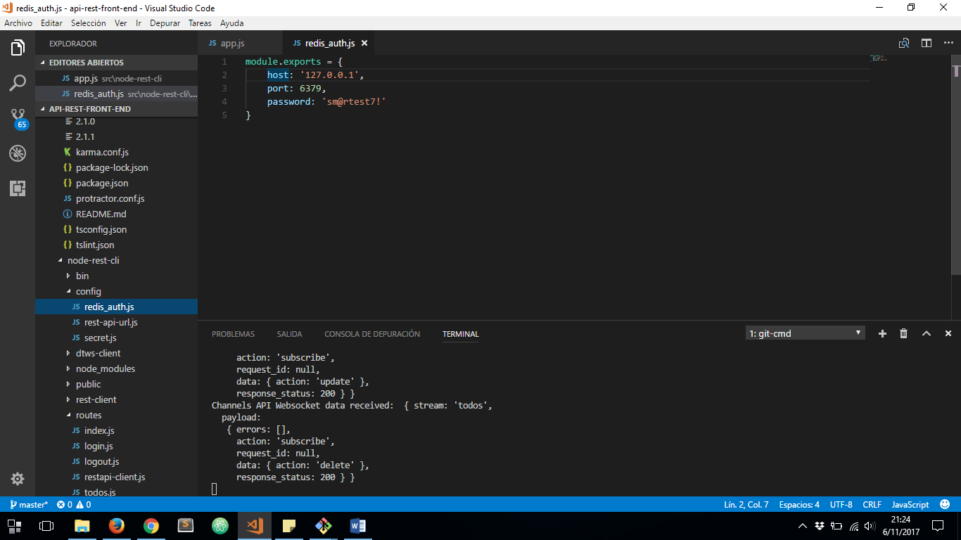

AND THEN WE MUST SECIFY THAT CREDENTIALS ON EACH REDIS CLIENT:

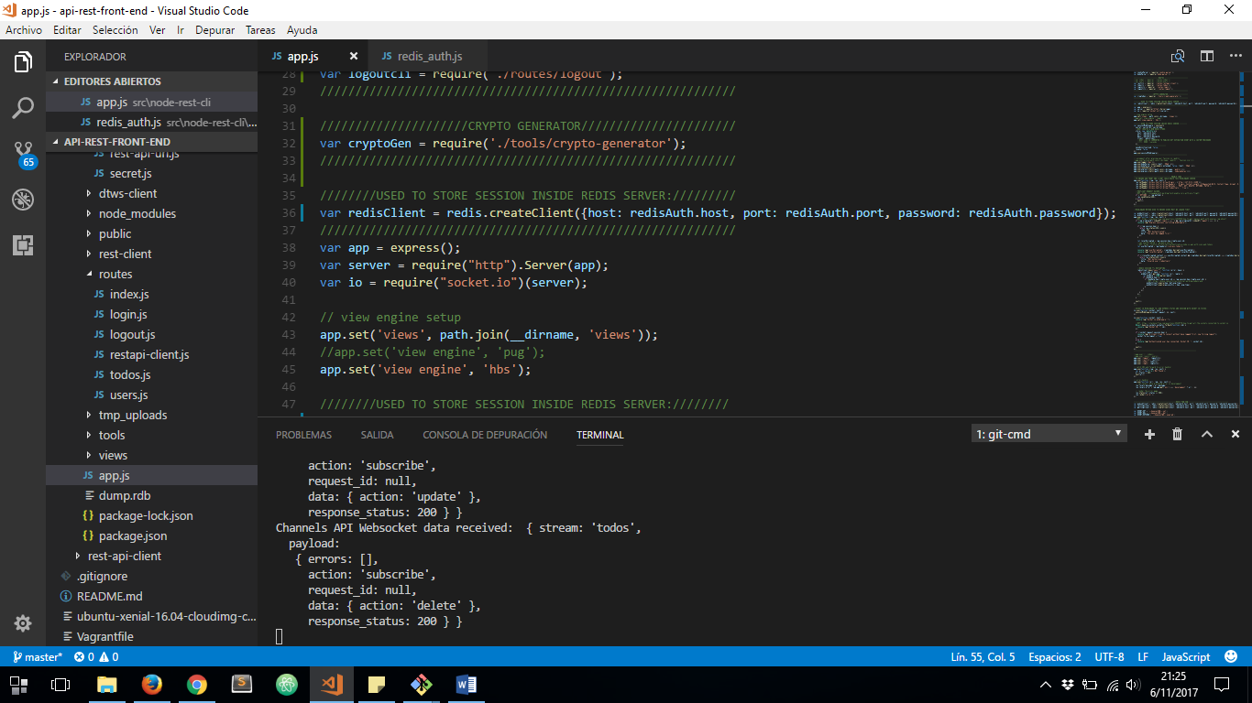

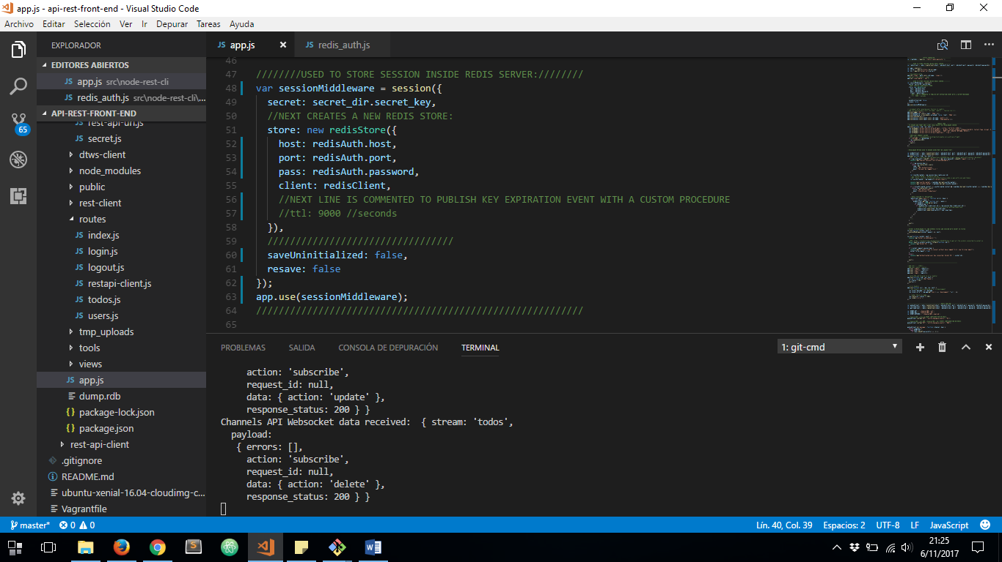

AND THAT’S ALL